Lab assignment 9

Task 1: The task here was to create an image classification system that could classify the images based on training data collected from Instagram. The following were the steps performed to achieve the needed.
- Create an access token with instagram.
- Collect images on the tags of Music, Movie, Sport, Food and USElections.
- Perform training of the model with the following categories as input.
- Run the instagram stream to randomly pick an image from one of the above categories.
- Test the image received and predict its category.
PFB the result for the Image Classification.
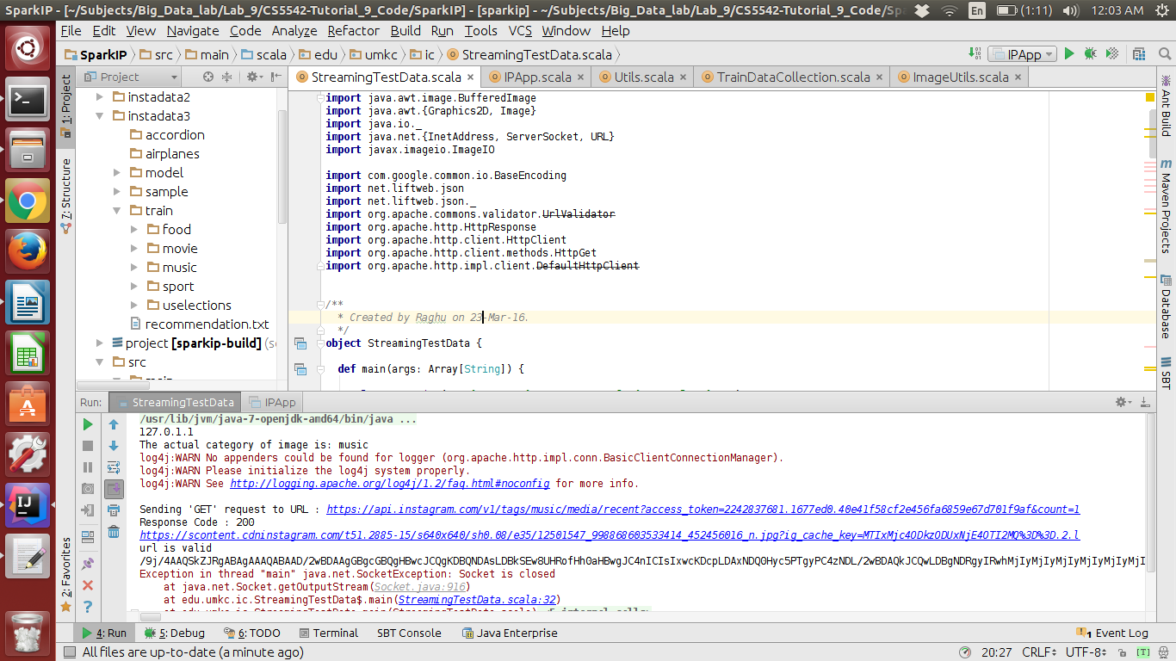
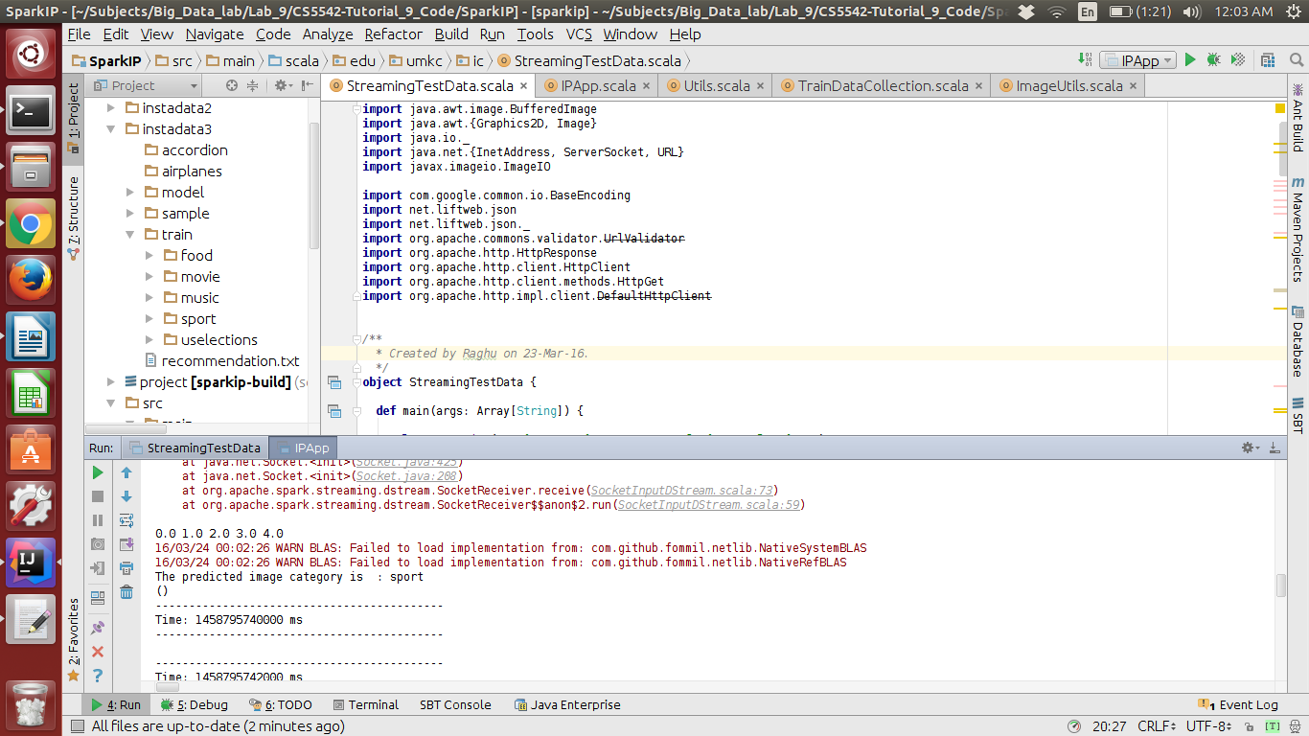

Task 2:
The task here was to create a recommendation system that can recommend category of images to the user based on his image from Instagram. The following steps were performed to achieve the given task.
- Create a server side socket that can get Instagram data based on a random tag that as previously used in the classification process.
- Get Image and caption from the user.
- Assign User Id based on the first letter of the user.
- Assign category id to each of the category selected.
- Train the model with data collected from Instagram.
- Then read data from the socket stream of Instagram to get one tag based row of data.
- For the caption part of the Instagram data calculate the sentiment using NLP sentiment analyzer.
- Then perform the testing on the data with the format UserId, TagId, SentimentRating
- This would give the recommendations for the user based on his TagID and SentimentRating.
PFB the result for the recommendation system.

